library(readr)

## Warning: package 'readr' was built under R version 4.1.2

data <- read_csv("FaithfulFaces.csv")

## Rows: 170 Columns: 7  
## ── Column specification ────────────────────────────────────────────────────────  
## Delimiter: ","  
## chr (2): FaceSex, RaterSex  
## dbl (5): SexDimorph, Attract, Cheater, Trust, Faithful  
##   
## ℹ Use `spec()` to retrieve the full column specification for this data.  
## ℹ Specify the column types or set `show_col_types = FALSE` to quiet this message.

attach(data)

head(data)

## # A tibble: 6 × 7  
## SexDimorph Attract Cheater Trust Faithful FaceSex RaterSex  
## <dbl> <dbl> <dbl> <dbl> <dbl> <chr> <chr>   
## 1 4.9 2 1 4.12 6.29 F M   
## 2 2.58 2.08 1 4 6.59 F M   
## 3 4.3 2.67 1 3.94 5.82 F M   
## 4 4.08 2.92 0 4.12 5.41 F M   
## 5 4.5 3.5 0 3.24 4 F M   
## 6 2 1.83 0 4.65 6.65 F M

plot(Faithful~Attract)  
model = lm(Faithful~Attract)  
abline(model)

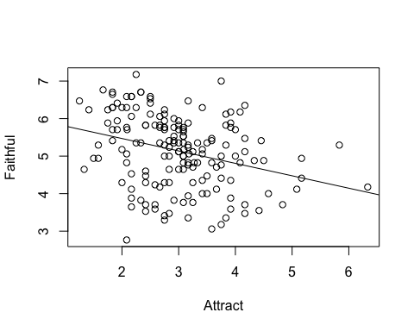

summary(model)

##   
## Call:  
## lm(formula = Faithful ~ Attract)  
##   
## Residuals:  
## Min 1Q Median 3Q Max   
## -2.6768 -0.6395 0.1475 0.6757 2.1106   
##   
## Coefficients:  
## Estimate Std. Error t value Pr(>|t|)   
## (Intercept) 6.13211 0.25286 24.251 < 2e-16 ***  
## Attract -0.33138 0.08117 -4.083 6.87e-05 ***  
## ---  
## Signif. codes: 0 '***' 0.001 '**' 0.01 '*' 0.05 '.' 0.1 ' ' 1  
##   
## Residual standard error: 0.9159 on 168 degrees of freedom  
## Multiple R-squared: 0.09026, Adjusted R-squared: 0.08485   
## F-statistic: 16.67 on 1 and 168 DF, p-value: 6.871e-05

anova(model)

## Analysis of Variance Table  
##   
## Response: Faithful  
## Df Sum Sq Mean Sq F value Pr(>F)   
## Attract 1 13.984 13.9843 16.669 6.871e-05 ***  
## Residuals 168 140.943 0.8389   
## ---  
## Signif. codes: 0 '***' 0.001 '**' 0.01 '*' 0.05 '.' 0.1 ' ' 1

model = lm(Faithful~Attract+Trust+SexDimorph)  
summary(model)

##   
## Call:  
## lm(formula = Faithful ~ Attract + Trust + SexDimorph)  
##   
## Residuals:  
## Min 1Q Median 3Q Max   
## -1.60277 -0.40312 -0.02402 0.45428 1.59068   
##   
## Coefficients:  
## Estimate Std. Error t value Pr(>|t|)   
## (Intercept) 4.76084 0.36033 13.213 < 2e-16 ***  
## Attract -0.28095 0.08026 -3.500 0.000597 ***  
## Trust 0.66589 0.07035 9.465 < 2e-16 ***  
## SexDimorph -0.39846 0.06644 -5.997 1.22e-08 ***  
## ---  
## Signif. codes: 0 '***' 0.001 '**' 0.01 '*' 0.05 '.' 0.1 ' ' 1  
##   
## Residual standard error: 0.6206 on 166 degrees of freedom  
## Multiple R-squared: 0.5873, Adjusted R-squared: 0.5798   
## F-statistic: 78.74 on 3 and 166 DF, p-value: < 2.2e-16

anova(model)

## Analysis of Variance Table  
##   
## Response: Faithful  
## Df Sum Sq Mean Sq F value Pr(>F)   
## Attract 1 13.984 13.984 36.307 1.055e-08 ***  
## Trust 1 63.153 63.153 163.962 < 2.2e-16 ***  
## SexDimorph 1 13.851 13.851 35.962 1.220e-08 ***  
## Residuals 166 63.938 0.385   
## ---  
## Signif. codes: 0 '***' 0.001 '**' 0.01 '*' 0.05 '.' 0.1 ' ' 1

cor(data[0:5])

## SexDimorph Attract Cheater Trust Faithful  
## SexDimorph 1.00000000 0.60426743 -0.02461228 -0.06839070 -0.5988680  
## Attract 0.60426743 1.00000000 -0.01318595 0.36435171 -0.3004394  
## Cheater -0.02461228 -0.01318595 1.00000000 -0.05653456 -0.1058720  
## Trust -0.06839070 0.36435171 -0.05653456 1.00000000 0.4851078  
## Faithful -0.59886800 -0.30043937 -0.10587203 0.48510783 1.0000000

plot(data[0:5])

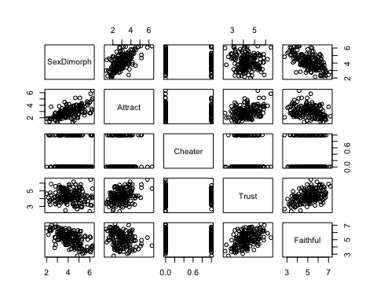

data <- read_csv("Meniscus.csv")

## Rows: 18 Columns: 4  
## ── Column specification ────────────────────────────────────────────────────────  
## Delimiter: ","  
## dbl (4): Method, FailureLoad, Displacement, Stiffness  
##   
## ℹ Use `spec()` to retrieve the full column specification for this data.  
## ℹ Specify the column types or set `show_col_types = FALSE` to quiet this message.

attach(data)

head(data)

## # A tibble: 6 × 4  
## Method FailureLoad Displacement Stiffness  
## <dbl> <dbl> <dbl> <dbl>  
## 1 1 97.3 16.9 8.3  
## 2 1 106. 20.2 7.2  
## 3 1 118. 20.1 6.3  
## 4 1 99.7 15.7 7.3  
## 5 1 106. 13.9 8.7  
## 6 1 84.2 14.9 8.7

plot(Stiffness~Displacement)  
model = lm(Stiffness~Displacement)  
abline(model)

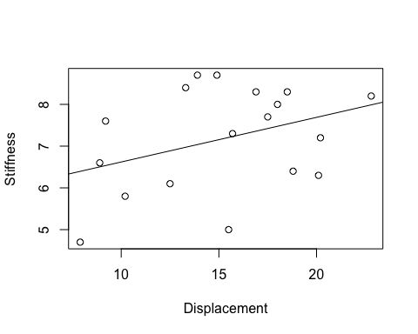

summary(model)

##   
## Call:  
## lm(formula = Stiffness ~ Displacement)  
##   
## Residuals:  
## Min 1Q Median 3Q Max   
## -2.2083 -0.8280 0.1543 0.8992 1.6628   
##   
## Coefficients:  
## Estimate Std. Error t value Pr(>|t|)   
## (Intercept) 5.55082 1.06927 5.191 8.92e-05 ***  
## Displacement 0.10693 0.06756 1.583 0.133   
## ---  
## Signif. codes: 0 '***' 0.001 '**' 0.01 '*' 0.05 '.' 0.1 ' ' 1  
##   
## Residual standard error: 1.196 on 16 degrees of freedom  
## Multiple R-squared: 0.1354, Adjusted R-squared: 0.08134   
## F-statistic: 2.505 on 1 and 16 DF, p-value: 0.133

anova(model)

## Analysis of Variance Table  
##   
## Response: Stiffness  
## Df Sum Sq Mean Sq F value Pr(>F)  
## Displacement 1 3.5855 3.5855 2.5052 0.133  
## Residuals 16 22.8995 1.4312

library(dplyr)

## Warning: package 'dplyr' was built under R version 4.1.2

##   
## Attaching package: 'dplyr'

## The following objects are masked from 'package:stats':  
##   
## filter, lag

## The following objects are masked from 'package:base':  
##   
## intersect, setdiff, setequal, union

library(tidyverse)

## Warning: package 'tidyverse' was built under R version 4.1.2

## Warning: package 'ggplot2' was built under R version 4.1.2

## Warning: package 'tibble' was built under R version 4.1.2

## Warning: package 'tidyr' was built under R version 4.1.2

## Warning: package 'purrr' was built under R version 4.1.2

## Warning: package 'stringr' was built under R version 4.1.2

## Warning: package 'forcats' was built under R version 4.1.2

## Warning: package 'lubridate' was built under R version 4.1.2

## ── Attaching core tidyverse packages ──────────────────────── tidyverse 2.0.0 ──  
## ✔ forcats 1.0.0 ✔ stringr 1.5.0  
## ✔ ggplot2 3.4.2 ✔ tibble 3.2.1  
## ✔ lubridate 1.9.2 ✔ tidyr 1.3.0  
## ✔ purrr 1.0.1

## ── Conflicts ────────────────────────────────────────── tidyverse_conflicts() ──  
## ✖ dplyr::filter() masks stats::filter()  
## ✖ dplyr::lag() masks stats::lag()  
## ℹ Use the conflicted package (<http://conflicted.r-lib.org/>) to force all conflicts to become errors

means <- data %>%   
 group_by(Method) %>%   
 summarize(mean_stiffness = mean(Stiffness))  
means

## # A tibble: 3 × 2  
## Method mean_stiffness  
## <dbl> <dbl>  
## 1 1 7.75  
## 2 2 6.1   
## 3 3 7.7

library(effsize)  
  
effect_size <- cohen.d(Stiffness[Method == 3], Stiffness[Method == 2])  
effect_size

##   
## Cohen's d  
##   
## d estimate: 1.511858 (large)  
## 95 percent confidence interval:  
## lower upper   
## 0.05319861 2.97051717

data <- read_csv("Fluor.csv")

## Rows: 51 Columns: 2  
## ── Column specification ────────────────────────────────────────────────────────  
## Delimiter: ","  
## dbl (2): Calcium, ProteinProp  
##   
## ℹ Use `spec()` to retrieve the full column specification for this data.  
## ℹ Specify the column types or set `show_col_types = FALSE` to quiet this message.

attach(data)

head(data)

## # A tibble: 6 × 2  
## Calcium ProteinProp  
## <dbl> <dbl>  
## 1 -10.1 0.145  
## 2 -9.98 0.224  
## 3 -9.35 0.220  
## 4 -9.10 0.334  
## 5 -9.01 0.379  
## 6 -8.94 0.409

plot(ProteinProp~Calcium)  
model = lm(ProteinProp~Calcium)  
abline(model)

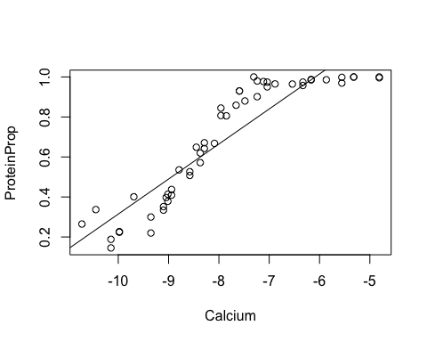

summary(model)

##   
## Call:  
## lm(formula = ProteinProp ~ Calcium)  
##   
## Residuals:  
## Min 1Q Median 3Q Max   
## -0.22712 -0.09454 0.00176 0.10410 0.21375   
##   
## Coefficients:  
## Estimate Std. Error t value Pr(>|t|)   
## (Intercept) 2.06586 0.08876 23.27 <2e-16 ***  
## Calcium 0.17514 0.01107 15.82 <2e-16 ***  
## ---  
## Signif. codes: 0 '***' 0.001 '**' 0.01 '*' 0.05 '.' 0.1 ' ' 1  
##   
## Residual standard error: 0.1199 on 49 degrees of freedom  
## Multiple R-squared: 0.8363, Adjusted R-squared: 0.8329   
## F-statistic: 250.3 on 1 and 49 DF, p-value: < 2.2e-16

anova(model)

## Analysis of Variance Table  
##   
## Response: ProteinProp  
## Df Sum Sq Mean Sq F value Pr(>F)   
## Calcium 1 3.5957 3.5957 250.26 < 2.2e-16 ***  
## Residuals 49 0.7040 0.0144   
## ---  
## Signif. codes: 0 '***' 0.001 '**' 0.01 '*' 0.05 '.' 0.1 ' ' 1

plot(model)

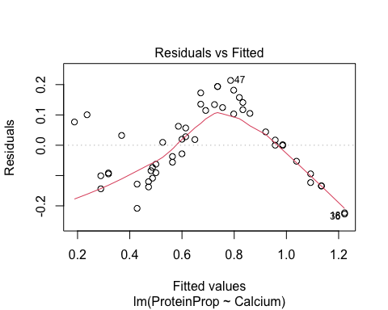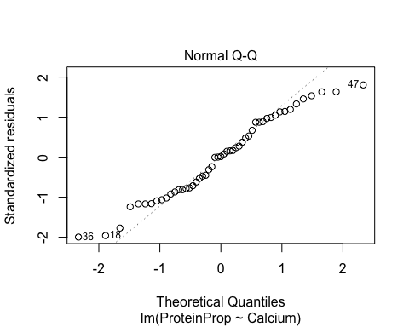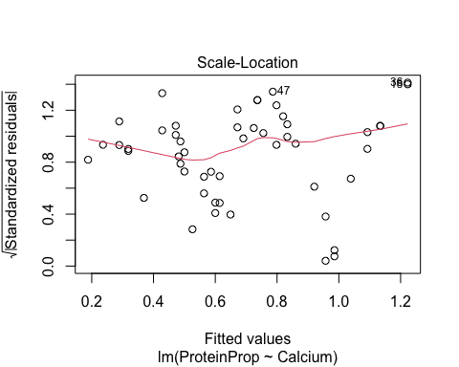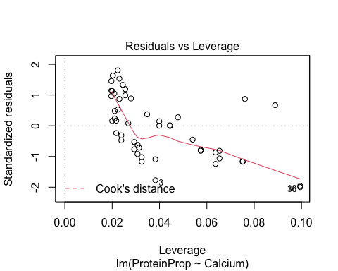

newx = data.frame(Calcium=-8.5)  
predict.lm(model, newx, interval='confidence')

## fit lwr upr  
## 1 0.5772151 0.5407123 0.6137179

predict.lm(model, newx, interval='prediction')

## fit lwr upr  
## 1 0.5772151 0.3335849 0.8208452